Homework Page
(Unit 3 --- Week 9)

_____________________________________
(Name)

Topic | Monday | Tuesday | Wednesday | Thursday
Volume of a rectangular prism | 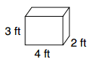 | 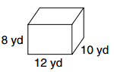 | 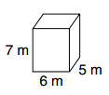 | 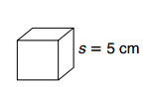
Simplify the expression
Define a variable, and translate the words to numbers | Four times more money than Elliot | half as many pages as George | 6 years less than Tracy’s age | 6 more hours of study than in reading
Translate the words to numbers | Three times x | four is added to p | Take two away from Q | The product of five and y
Word Problems | Simplify the expression:  4(2a + 6) - 5a + 4(3a + 5f) - 5f - a | Write an expression that describes:  Q - 6 | Downloading music costs .99 per song, plus a registration fee of $26 which expression represents the total cost to download x songs? | 3. Admission to the movies costs 10$ for adults and 6$ for children. What is the total cost of the trip for 7 adults and 6 children?

